When International Collaborations Collide – by Michael Gates
Michael Gates is Vice Chairman of Richard Lewis Communications, one of the world’s leading cross-cultural training and consultancy service providers. He is also an Associate Fellow of Saïd Business School, University of Oxford. He is based in Helsinki, Finland.
The challenge
International collaboration is a fact of life for many of us in all walks of business, governmental and academic environments. It cannot be avoided. But often we can feel the frustration of collaborating with people who have different world-views from ourselves and diverse ways of communicating, dealing with time and building trust.
I recently spoke to the HR director of a large global engineering corporation where much project work is done in global, dispersed virtual teams. He said that when young talented engineers are promoted to lead international projects, they typically say ‘never again!’ at the end. They rose to a leadership role because of their technical skills – but the challenge of managing diversity virtually, in different time zones, was just too much. They were generally logical, task-oriented individuals who came to realise that technical expertise and task-orientation were not the key to making multicultural teams a success. Something else was required – human beings are not rational or as malleable as a spread-sheet or project plan. As the German philosopher Immanuel Kant said: ‘Out of the crooked timber of humanity, no straight thing was ever made.’
The same can be true in any form of international collaboration.
Research
Research by DiStefano and Maznevski into diverse collaborative teams has shown they are often a destructive, unproductive mess. However, when they do gel, their performance is better and more creative than any homogeneous team.
So the question is, naturally, what are they doing differently?
- They have a high degree of self-awareness – both individually and as a team. This tends not to come naturally: it is very hard to see ourselves as others see us. Assessment and measurement can help. This could be through one of the many psychometric tests on the market, through videoing team meetings, or through a cultural assessment. CultureActive (www.cultureactive.com ) is one such assessment, based on the Lewis Model of Culture, which classifies cultures into three main types, as follows:

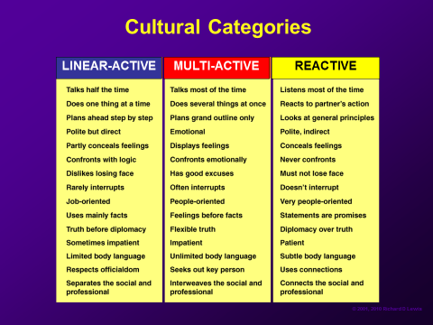

Germanic, Anglo-Saxon and Nordic cultures tend to be more linear-active. Latin, African and Middle Eastern cultures more multi-active and East Asian cultures more reactive. Of course individuals from any culture can get assessment scores a long way from what is the statistical average for their culture.
Team members (or whole departments or companies) are automatically mapped onto a triangle – as below - once everyone has completed an assessment, and the results are used to heighten awareness and generate open discussion about how to work together more productively.

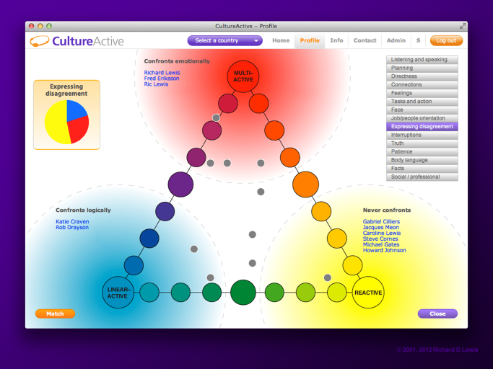

- They are good at closing, or bridging the gaps between diverse team members. A key way to achieve this is through modifying our communication style, and putting ourselves in the shoes of our listeners. I once experienced a great example of this technique on a Lufthansa flight. We hit really bad turbulence, and the pilot explained the situation in a highly ‘Germanic’ way to the German passengers – full of technical details, context and background, in long sentences with many clauses. There is surely a connection between the complexity of the grammatically synthetic German language and a German desire for complex explanations. When the pilot switched to his perfect American English, all he said was ‘Well….as you can see, we are on a bit of a rollercoaster, so just sit back, tighten your seatbelts and enjooooooy the ride!’ For the Americans, the fact that the pilot sounded relaxed and humorous was enough. Team members need to be aware their own and others’ communication styles and at least try and come half way. Many misunderstandings are also caused by a mixture of direct and indirect styles within the team. The British philosopher, John Locke, believed that the vast majority of human misunderstanding was actually verbal.
- They are good at integrating different approaches. It is all very well having diverse skills, but often insufficient attention is paid to actually doing anything about it. Communication plays a part here as well. Probably of all three cultural types, the most under-used, least integrated in international teams is the ‘reactive’. Reactives tend to be deep thinkers who may have the best ideas at all. Yet because they tend to think before speaking, to be non-interruptive, and not to initiate, their value can be wasted. One idea is for the team to do a Cultural SWOT Analysis together, focusing on the diverse skills they have, then plan how to use them. None of this is what the Americans would call ‘rocket science’. But it is amazing how easily we forget to do the simple things that could really improve our performance.
The Economist Intelligence Unit’s 2012 report ‘Competing Across Borders’ claimed that a significant number of organisations are stuck at the stage where the benefits of overcoming cultural barriers are recognized but not enough is done to address the challenge. This is true not only for organisations as a whole, but at team level, where it ought to be relatively easy to do something about it.
Trust
In the end, trust is the ground-rock for any successful human interaction, yet trust is built in different ways across cultures, as in the diagram below:

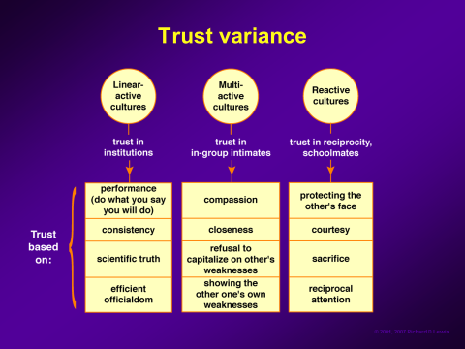
Being aware of different trust-building strategies, and applying them within your teams, can do no harm, and will almost certainly lead to better results. If you are a multi-active who likes to exaggerate and promise the earth in order to keep enthusiasm high, think for a moment about the effect this may have on a linear-active. If you are a logical and direct linear-active, consider that you may make your reactive colleague lose face. If you are reactive, remember that trying to save the face of your linear- or multi-active team members may not be as important to them as understanding your opinions clearly.
Showing value
Your organisation’s human resource and training people have a great role to play in developing ways of demonstrating to senior management the importance of getting cross-cultural collaboration right, and of measuring the results in doing so. It is intangible stuff, so not easy, but not impossible.
Chinese-American collaboration
Some key differences to bear in mind when the Chinese and Americans collaborate are as follows:
- US reasoning tends to be absolute and based on facts, figures and logic
- Chinese approaches tend to be more relational
- For Americans truth tends to be scientific, and black and white
- Chinese truth may be relative and many-sided
- US disagreement tends to be direct and separate the person from the problem
- Chinese disagreement tends to be more indirect in order to save face all round
- Americans can actually enjoy conflict, as it is seen as a vigorous airing of opinions
- The Chinese tend to value harmony more
- Americans tend to drive individual agendas
- The Chinese tend to have collective agendas
- Americans tend to focus on one thing
- The Chinese tend to be more holistic
- Americans tend to be impatient and want quick results
- The Chinese tend to be patient and think more long-term
- Americans build trust through demonstrations of technical competence, consistency, reliability and scientific truth
- The Chinese tend to build trust through guanxi, sacrifice and reciprocity
Of course, in the end, we need to focus on our commonalities, and - where there are fewer commonalities - on common goals, and on basic human needs. The latter two things can often be the same for both parties – the secret is in managing different behavioural and communicative expectations and ways of reaching those goals.

